**Practical name 1 :- Demostration of creating database**

**Batch: B6**

**Student name: Bhagyashree sharad shukla**

**Roll no: 182**

create database bhagyashree;

use bhagyashree;

**output:**

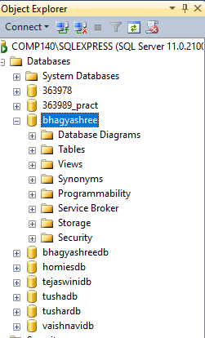

**Practical name 2 :-Create table insert 10 records in it**

**Batch: B6**

**Student name: Bhagyashree sharad shukla**

**Roll no: 182**

create table student(fname varchar(10),lname varchar(20),age int);

select*from student;

insert into student values('priti','sarode',18);

insert into student values('nidhi','bonde',18);

insert into student values('sakshi','shukla',18);

insert into student values('sakshi','shukla',18);

insert into student values('sakshi','shukla',18);

insert into student values('sakshi','shukla',18);

insert into student values('sakshi','shukla',18);

insert into student values('sakshi','shukla',18);

insert into student values('sakshi','shukla',18);

insert into student values('sakshi','shukla',18);

select*from student;

**output:**

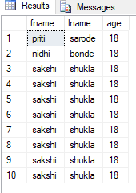

**Practical name 3 :- Demostration of insert update and delete**

**Batch:- B6**

**Student name:- Bhagyashree sharad shukla**

**Roll no:- 182**

use bhagyashree;

select *from student;

update student set fname='nidhi' where fname='niraj';

**output:**

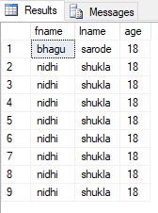

use bhagyashree;

select *from student;

update student set fname='nidhi' where fname='niraj';

delete from student where lname='shukla';

**output:**

